# C2-S2 - THEORY ARRAYS 2D

**EXERCICE 1**

**PROBLEM:**

Captain America is represented by a star (*) and empty cells are represented by a zero (0).

You need to move Captain America of one step on the right.

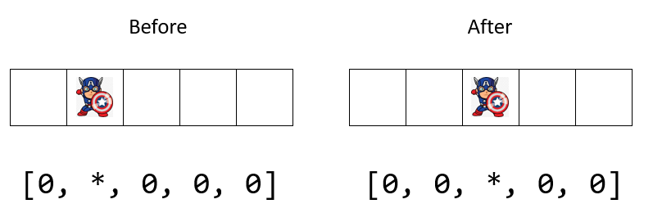

**INPUT**

* An array of 5 character (zero or *)

*Note: Captain America is never on the last cell for this first exercise*

**OUPUT**

* The new array after you have moved Captain America on the right.

**Q1** – This program contains 2 mains steps; can you complete the description the 2 steps?

**Step 1**: Find the position of ………………*……………………………

**Step 2**: Write 0 at the position of …………………*…………………………. And write * at the position of… …………………0…………………………

**Q2** – Write the code on space below to complete step 1 and step 2

*TIPS: you should use a function to write this code*

*// your code*

def indexStar(array):

for i in range(len(array)):

if array[i] == “ * “ :

position=i

return position

list = ["0", "*", "0", "0", "0"]

result = starPosition(list)

list[result]="0"

list[result+1]="*"

print(list)

**Q3** – Share and discuss in groups of 3.

**Q4** – Code on your computer.

**EXERCICE 2**

**PROBLEM:**

Now Captain America can move left or right, depending on the input direction.

This time:

* if Captain America in on the first cell, he cannot go left (he stays at the same position)
* if Captain America in on the last cell, he cannot go right (he stays at the same position)

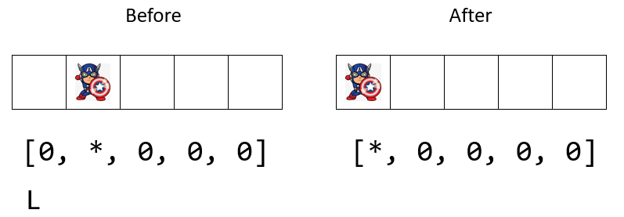

*Here Captain America can go left*

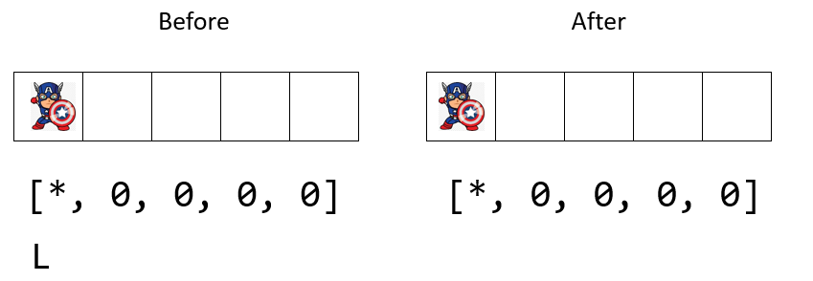

*Here Captain America cannot go left So he stays at the same position*

**INPUT**

* An array of 5 character (zero or *)
* Direction, a character (R or L)

**OUPUT**

* The new array after you have moved Captain America on left or right.

**Q1** – What do you need to update on your previous code?

* I need to…
* I need to…
* I need to…

**Q2** – Write the code on space below:

*// your code*

Letter = str(input())

array = eval(input())

for i in range(len(array)):

if letter == “R”:

**Q3**– Share and discuss in groups of 3.

**Q4** – Code on your computer.

**EXERCICE 3**

**PROBLEM:**

Now Captain America can move left or right but also up and down!!

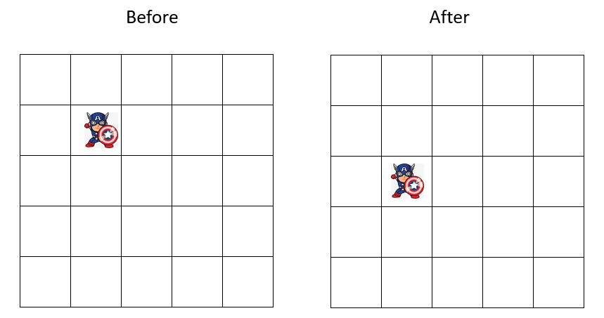

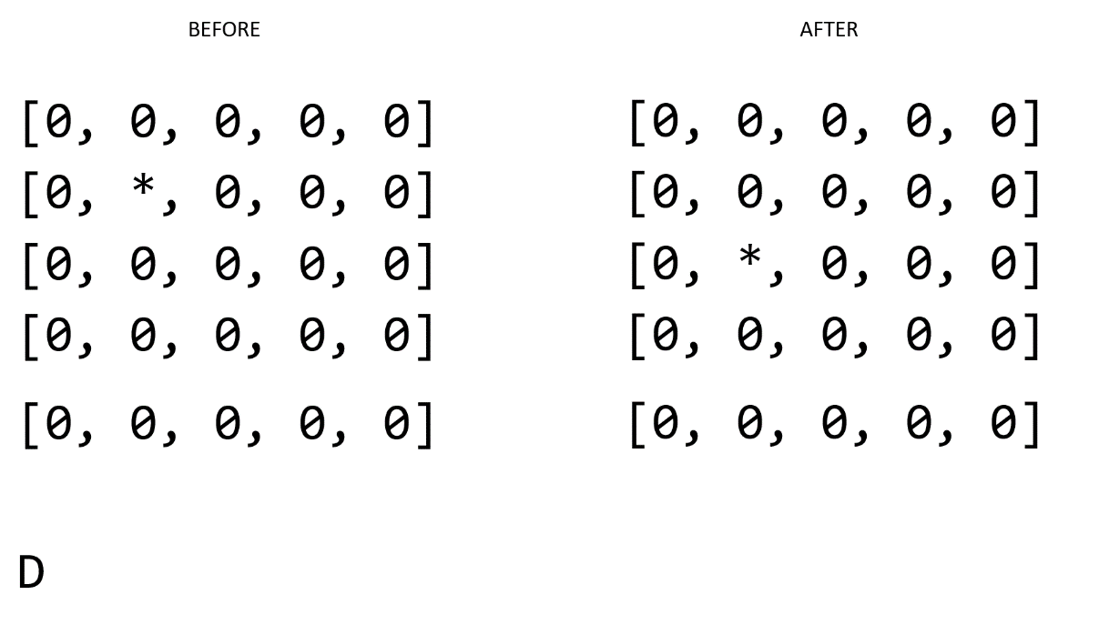

**INPUT**

* An array2D composed of (zero or *)
* Direction, a character (R, L, U, D)

**OUPUT**

* The new array after you have moved Captain America on left or right and up or down.

**Q1** – What do you need to update on your previous code?

* I need to…
* I need to…
* I need to…

**Q2** – Write the code on space below:

*// your code*

**Q3** – Share and discuss in groups of 3.

**Q4** – Code on your computer.

**EXERCICE 4**

**PROBLEM:**

Now Captain America can move left or right but also up and down!!

This time:

* if Captain America in on the first column, he cannot go left (he stays at the same position)
* if Captain America in on the last column, he cannot go right (he stays at the same position)
* if Captain America in on the first row, he cannot go up (he stays at the same position)
* if Captain America in on the last row, he cannot go down (he stays at the same position)

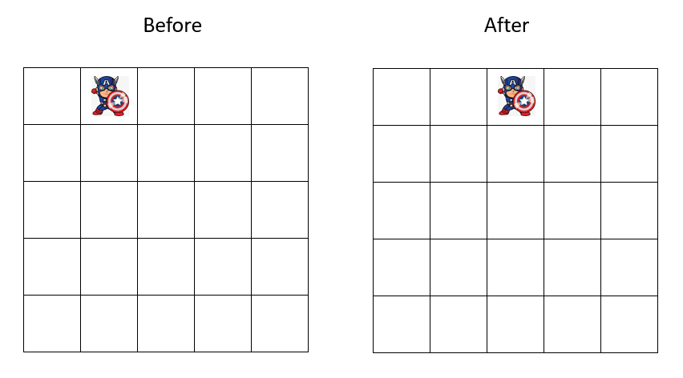

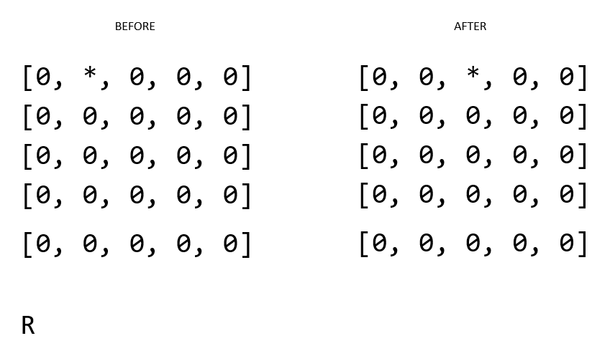

*Here Captain America can go right*

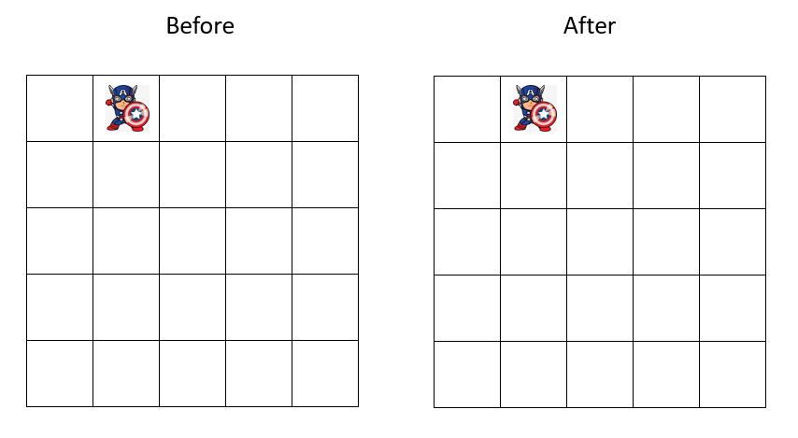

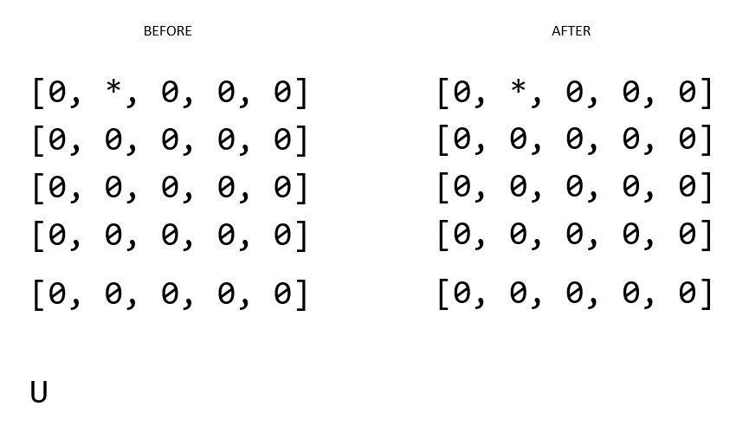

*Here Captain America cannot go up So he stays at the same position*

**INPUT**

* An array2D composed of (zero or *)
* Direction, a character (R, L, U, D)

**OUPUT**

* The new array after you have moved Captain America on left or right and up or down.

**Q1** – What do you need to update on your previous code?

* I need to…
* I need to…
* I need to…

**Q2** – Write the code on space below:

*// your code*

**Q3** – Share and discuss in groups of 3.

**Q4** – Code on your computer.